Using this document
The easiest way to use this document is to keep a copy of this original template (since it contains all the instructions) and then save a copy of this file using the intended file-name for your proposal. Files should be saved in DOC-format and filenames should indicate the kind of proposal and name of the presenting author. So, for example, a paper by Dufus and Smith should have the filename dufus.doc. When considering page limits, make sure you have not changed font sizes, margins, or paper size!
Once you have your copy, the simplest way to work with the styles is to start typing over what is already here. If you need a heading or paragraph of a certain style in another part of the paper, simply copy and paste one that you already have. You just need to make sure you include the whole paragraph including the paragraph mark at the end (to make paragraph marks and spaces visible, get Word to “Show Formatting”). You can also see which style applies to a particular paragraph by inserting the cursor in the paragraph and looking at the “style” box visible in the Formatting Toolbar (usually next to the boxes showing the Font and Font Size). You can change the style of a paragraph by highlighting the paragraph and selecting the desired style from the selection shown in that style box; this may be useful if you need to paste in some material from another document. If you cannot see the Formatting Toolbar you can make it visible using the “View” menu.
Table. Figure
Ensure that tables and figures do not spread outside the margins of the page. Try to avoid the use of too much grey scale, as this does not always print well; a good way to test is to make a photocopy of your document after printing it out. If the photocopy looks good, then it should print well. The author should check if it is possible to read and understand the pictures before they submit their papers. Pictures must not be embedded, but placed alone with text above and below.

- Documents top 2,5 – bottom 2,2, - left 2,5 – right 2,3 – header 1,3 –footer 1,1 – page 16,97 x 23,99

Font Garamond

Language English UK or USA. Please be consistent throughout the paper, also with regard to dates and symbols.

FOR THOSE WHO DO NOT WANT TO USE THE TEMPLATE WE ADD SPECIFIC INFORMATION
Secondary teachers in the unified Italy: a group portrait with a zoom TitleTurin point 18, bold, line space 10pt, after 6, based on Normale; NormalTurin, next style NormalFirstParagraphTurin
Fulvia Furinghetti NormalFirstParagraphTurin based on Normale;NormalTurin
Dipartimento di Matematica dell’Università di Genova. Italy, next style Normale;NormalTurin
Abstract TitleAbstractTurin based on TitleReferenceTurin, next style AbstractTurinFirstParagrap
After the unification of Italy in 1861 one of the main problems was the creation of a system of instruction to plan curricula and programs, teacher education, textbooks. Mathematicians were very active in this construction and some of them also had important official roles in the government. Abstract TurinFirst Paragaph based on AbstractTurin, next style AbstractTurin.
In this context important initiatives for the professional development of mathematics teachers were carried out: publication of good mathematics textbooks and books on mathematical culture for teaching, and the foundation of journals and associations. Mathematics teachers occupied a leading position in these actions. In this concern a question arises: “Who were the teachers animating these important initiatives?” In this paper I present some elements that help to answer this question by outlining some general characteristics of the mathematics teacher profession of those times and by illustrating the way the profession was lived by the founder of an important journal for mathematics teachers. AbstractTurin line space 10 pt, based on Normale;NormalTurin, next style TitleParagraphTurin
Keywords: history, ICMI, mathematicians, mathematics education Keywords
Introduction TitleParagraphTurin point 13, bold, lne space 10 pt, before 6 pt, after 6 point, keep with the next, next style NormalFirstParagraphTurin
Massimo D’azeglio, a politician very active in the period preparing Italian unification (that happened in 1861), wrote in his book of memories I miei ricordi that, after having built the new nation of Italy, it was necessary to build the Italians (“purtroppo s’è fatta l’Italia, ma non si fanno gli italiani”). I deem that teachers deserve a particular place among people who played a role in achieving the objective of “building Italians”. Their contribution not only resides in their primary task of teaching, but also in the fact that, due to the system of recruitment based on a national concorso (competition), they often obtained their post in school far from their home town. This mobility, unusual in Italian society (then as now), promoted contacts among people with different customs, dialects, and backgrounds in the various regions. A real concrete contribution to the process of communication in the country was given by the foundation of professional journals and associations, and by the organization of local and national congresses. NormalFirstParagraphTurin based on Normale;NormalTurin, first line 0 space before
To grasp some aspects of the Italian school practice I follow Schubring’s claim that studies focused on teachers help “gaining access to the historical reality, the everyday life of teaching” (2006, p. 675). I consider some general characteristics of the mathematics teaching profession in the period of transition from the unification to 1923, when the reform proposed and carried out by the neo-idealist philosopher Giovanni Gentile, then Minister of Public Education, launched the new curricula in force (with some variations) in all the twentieth century. To highlight some shared beliefs and values of those times I focus on the action of an outstanding mathematics teacher. Normale;NormalTurinTurinGaramond, 11pt, first line 0,5 cm, justified, line space 12.

Table 1. PopulationCaptionTableTurin Garamond, 11pt, line space 10, before 9, after 3, keep with the next,
TableTurin, 10pt, based on NormalFirstParagraphTurin,
After the unification one of the main enterprises of the new government was to set a national system of instru Casati Law, promulgated in 1859 to r teaching as well as the respect of politicians for the mathematicians. Their action may be seen as the continuation of the participation of the scientists in the movement known as Italian Risorgimento that fostered the birth of the country, see (Bottazzini, 1981; Giacardi, to appear). NormalTurinAfterTableFigure, space before 9,
The first president of the NCTM, Charles M. Austin (1921), explained how he and the other organizers saw the problem:
Mathematics courses have been assailed on every hand. So-called the existing situation the National Council of Teachers of Mathematics was organized. (pp. 1–2)
The NCTM soon began to make recoimprovem NormalfFirstParagraphTurin

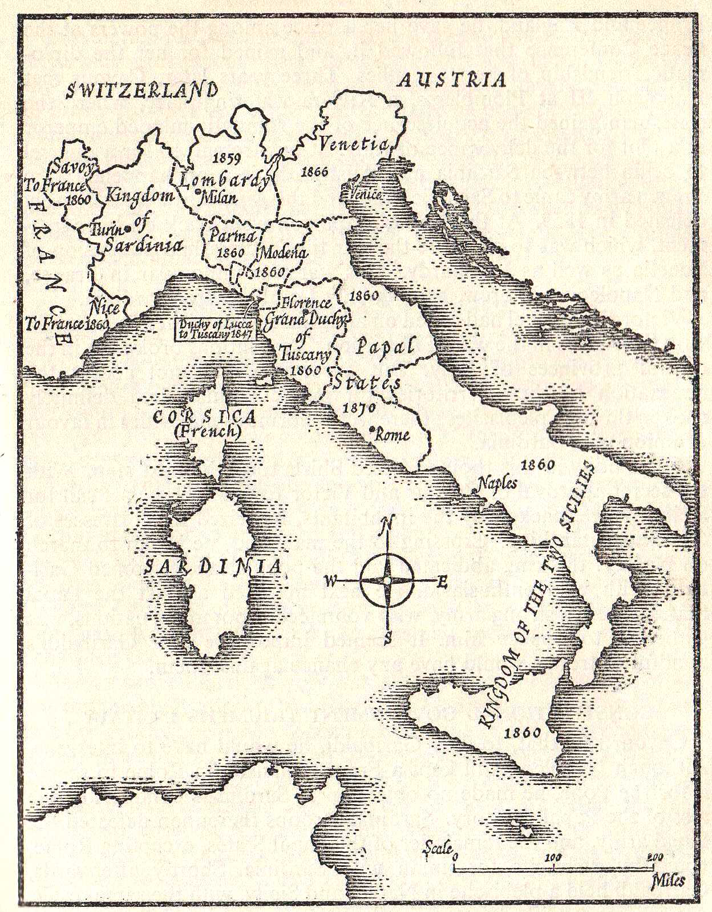FigureTurinbefore 12, centered
Fig. 1. Italy before unification. The dates in the map indicate the years in which the various states were annexed to the new nation (Weech, 1945, p. 787)CaptionFigureTurin
In the second half of nineteenth century Italian mathematical research lived a period of exceptional vitality, see (Cerruti, 1908; Segre, 1891; Tricomi, 1962; Volterra, 1909), and reached an international reputation witnessed by the acceptance of the Italian language in mathematical journals and later in the quadrennial International Congresses of Mathematicians (ICMs). This flourishing was paralleled by a great ferment in the school mathematics milieu and by the emergence of a group of noteworthy matheme level of professionalization reached by them is evidenced by the following initiatives carried out quite early after the establishment of the new system of education: NormalTurinAfterTableAndFigure 9 pt before, bases on NormalfFirstParagraphTurin
Political and social dimensionTitleSubParagraphsTurinbased on NormalfFirstParagraphTurin, Times 12, before 6, line space 14, keep with the next
Gaetano Fazzari, a pioneer in considering history of mathematics as a didactical tool for teaching, were reviewed by Smith (1907) and Karpinski (1918).
Giovanni Massa (Alba, May 9, 1850 - Milan, April 8, 1918) founded in 1874 Rivista di Matematica Elementare in Alba. The journal survived until 1885.
- Alberto Cavezzali (Reggio Emilia, February 20, 1848 - Bergamo, October 29, 1922) founded in Novara Il Piccolo Pitagora issued in 1883 and 1884.BulletedListTurin
- Gaetano Fazzari (Tropea, October 7, 1856 - Messina, July 13, 1935) founded Il Pitagora (addressed to students) in Avellino, issued from 1894 to 1919.
As a consequence of the Gentile Reform that town (Florence) in 1920, he taught in a villao NormalFirstParagraphTurin
Acknowledgment. I thank Leo Rogers for polishing the English of the present paper, Giuseppe Ferrera and Antonio Salmeri for providing documents. Acknowledgment.Turin Italic, 10pt, line space 10, before 12
ReferencesTitleReferencesTurin based on TitleParagraphTurin, 12, bold, after 3 pt, following stile ReferencesTurin
Berzolari, Luigi, & Bonola, Roberto (1909). Sopra una Enciclopedia di Matematiche Elementari. In Atti del II° congresso della “Mathesis” Società Italiana di Matematica (pp. 1-5). Padova: Premiata Società Coperativa. ReferencesTurin, 10pt, space line 10, based on NormalFirstParagraphTurin, second line 0,5
Borga, Marco, Fenaroli, Giuseppina, & Garibaldi, Antonio C. (2008). Ricordo di Alessandro Padoa (1868-1937). Epistemologia, 31, 133-152.
Chapman, Olive (2003). Facilitating peer interactions in learning mathematics: Teachers’ practical knowledge. In M. J. Høines & A. B. Fuglestad (Eds.), Proceedings of the 28th Conference of the International Group for the Psychology of Mathematics Education (Vol. 2, pp. 191-198). Bergen, Norway: PME.
Weech, William Nassau (Ed.) (1945). History of the World. London: Odhams.

Natucci (1939) reports that the book reviewed by Smith was translated into Russian by S. Galascin of Rostow in 1923. FootNotesTurin 9pt, space line 9. Based on NormalFirstParagraphTurin

